1. **There are 20 bricks of weight 3.4 Kg each and 30 bricks of weight 3.6 Kg each. Find the Mean, and Standard Deviation of weight for the whole bunch of 50 bricks?**

**Solution:**

= = = **3.52**

Variance of a population is, σ² = =

σ² = = = = 0.0096

Standard Deviation, **σ = 0.09797**

1. **Find the Mean, Standard Deviation of height for the following dataset.**

|  |  |
| --- | --- |
| Height (cm) | No of People |
| 150-156 | 2 |
| 157-163 | 14 |
| 164-170 | 15 |
| 171-177 | 20 |
| 178-184 | 7 |
| 185-191 | 10 |

**Solution:**

|  |  |  |  |  |  |  |
| --- | --- | --- | --- | --- | --- | --- |
|  | Height (cm) | No of People (f) | Mid-point of Height (x) | f*x | x-m | (x-m)² |
|  | 150-156 | 2 | 153 | 306 | -17.5 | 306.25 |
|  | 157-163 | 14 | 160 | 2240 | -10.5 | 110.25 |
|  | 164-170 | 15 | 167 | 2505 | -3.5 | 12.25 |
|  | 171-177 | 20 | 174 | 3480 | 3.5 | 12.25 |
|  | 178-184 | 7 | 181 | 1267 | 10.5 | 110.25 |
|  | 185-191 | 10 | 188 | 1880 | 17.5 | 306.25 |
| SUM |  | **68** | **1023** | **11678** |  | **857.5** |

Mean, μ = = = **171.7352**

In case we use other formula to calculate mean,

= **170.5**

Variance of a population is, σ² = = = **12.6102**

Standard Deviation, **σ = 3.551**

1. **Find the correlation coefficient for the following set of observations.**

|  |  |  |  |  |  |  |
| --- | --- | --- | --- | --- | --- | --- |
| X | 7 | 14 | 24 | 30 | 45 | 57 |
| Y | 24 | 34 | 45 | 50 | 61 | 69 |

**Solution:**

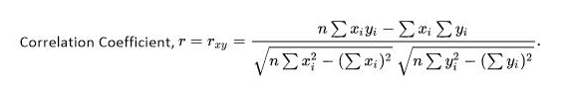

|  |  |  |  |  |  |
| --- | --- | --- | --- | --- | --- |
|  | x | y | x*y | x² | y² |
|  | 7 | 24 | 168 | 49 | 576 |
|  | 14 | 34 | 476 | 196 | 1156 |
|  | 24 | 45 | 1080 | 576 | 2025 |
|  | 30 | 50 | 1500 | 900 | 2500 |
|  | 45 | 61 | 2745 | 2025 | 3721 |
|  | 57 | 69 | 3933 | 3249 | 4761 |
| **SUM** | **177** | **283** | **9902** | **6995** | **14739** |

r = =

= = = = **0.9891**

Since ‘r’ is close to 1 (r = 0.9891) and the curve is almost linear, they are strongly related and positive.

1. **Find the correlation coefficient for the following data set and interpret the results.**

|  |  |  |
| --- | --- | --- |
| Vehicle model | Mileage (m/g) | Price $’000 |
| 1 | 19 | 14.94 |
| 2 | 19 | 14.8 |
| 3 | 20 | 24.76 |
| 4 | 20 | 14.93 |
| 5 | 20 | 13.95 |
| 6 | 21 | 17.88 |
| 7 | 21 | 11.65 |
| 8 | 22 | 17.9 |
| 9 | 23 | 21.5 |
| 10 | 24 | 13.25 |
| 11 | 25 | 9.6 |
| 12 | 17 | 13.95 |
| 13 | 28 | 13.07 |
| 14 | 32 | 6.6 |
| 15 | 33 | 9.41 |
| 16 | 34 | 5.87 |
| 17 | 35 | 6.49 |

**Solution:**

Let’s consider that based on mileage and other factors, price of the vehicle is decided.

So, let’s assume that, Mileage = x (independent) and Price = y (dependent)



|  |  |  |  |  |  |
| --- | --- | --- | --- | --- | --- |
| Vehicle model | Mileage (x) | Price (y) | xy |  |  |
| 1 | 19 | 14.94 | 283.86 | 361 | 223.2036 |
| 2 | 19 | 14.8 | 281.2 | 361 | 219.04 |
| 3 | 20 | 24.76 | 495.2 | 400 | 613.0576 |
| 4 | 20 | 14.93 | 298.6 | 400 | 222.9049 |
| 5 | 20 | 13.95 | 279 | 400 | 194.6025 |
| 6 | 21 | 17.88 | 375.48 | 441 | 319.6944 |
| 7 | 21 | 11.65 | 244.65 | 441 | 135.7225 |
| 8 | 22 | 17.9 | 393.8 | 484 | 320.41 |
| 9 | 23 | 21.5 | 494.5 | 529 | 462.25 |
| 10 | 24 | 13.25 | 318 | 576 | 175.5625 |
| 11 | 25 | 9.6 | 240 | 625 | 92.16 |
| 12 | 17 | 13.95 | 237.15 | 289 | 194.6025 |
| 13 | 28 | 13.07 | 365.96 | 784 | 170.8249 |
| 14 | 32 | 6.6 | 211.2 | 1024 | 43.56 |
| 15 | 33 | 9.41 | 310.53 | 1089 | 88.5481 |
| 16 | 34 | 5.87 | 199.58 | 1156 | 34.4569 |
| 17 | 35 | 6.49 | 227.15 | 1225 | 42.1201 |
| **SUM** | **413** | **230.55** | **5255.86** | **10585** | **3552.721** |

r =

=

= = = = **-0.712**

Threshold = = = = 0.475

**Observations: -**

1. r is negative, hence its Inverse correlation or negative correlation.
2. Magnitude of ‘r’ is 0.712, hence it’s a medium correlation coefficient
3. **Local ice cream shop keeps track of how much ice cream sell versus the noon temperature on that day. Here are their figures for the last 12 days. Identify if there is a linear or otherwise relationship between Ice Cream Sales and Temperature at noon of the day. Predict the Ice Cream sales if the noon temperature is 26.5 degree centigrade.**

|  |  |
| --- | --- |
| Temperature (centigrade) | Ice Cream Sales ($) |
| 14.2 | 215 |
| 16.4 | 325 |
| 11.9 | 185 |
| 15.2 | 332 |
| 18.5 | 406 |
| 22.1 | 522 |
| 19.4 | 412 |
| 25.1 | 614 |
| 23.4 | 544 |
| 18.1 | 421 |
| 22.6 | 445 |
| 17.2 | 408 |

**Solution:**

Based on the values, we can get the below graph

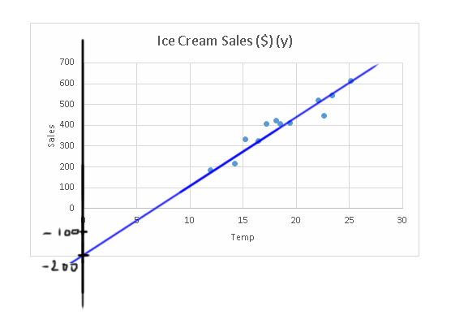

We know the general equation of line, y = mx+c,

where m is slope and c is y-intercept

Let’s derive the slope of the line, m = = = = 33.21

y-intercept, c = -200

so, the equation of the curve is,

y = 33.21x – 200

When x = 26.5, y = 33.21*26.5-200 = 880.065 – 200 = **680.065**

1. **Weight loss of a person is assumed to depend on the number of hours of exercise in gym. Observed values of these for 8 people are given in the table below. Validate if the assumption is right. Predict the weight loss for 70 hours of exercise in the gym.**

|  |  |
| --- | --- |
| Hours spent in gym | Weight loss in Kg |
| 100 | 15 |
| 75 | 11 |
| 80 | 15 |
| 90 | 14 |
| 60 | 8 |
| 50 | 9 |
| 25 | 2 |
| 40 | 5 |

**Solution:**

|  |  |  |
| --- | --- | --- |
|  | Hours spent in gym (x) | Weight loss in Kg (y) |
|  | 100 | 15 |
|  | 75 | 11 |
|  | 80 | 15 |
|  | 90 | 14 |
|  | 60 | 8 |
|  | 50 | 9 |
|  | 25 | 2 |
|  | 40 | 5 |
| **SUM** | **520** | **79** |
| **Average (Mean)** | **65** | **9.875** |

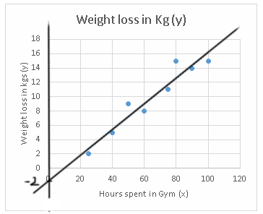

We know the general equation of line, y = mx+c,

where m is slope and c is y-intercept

Let’s derive the slope of the line, m = = = = 0.18

y-intercept, c = -2

so, the equation of the curve is,

y = 0.18x – 2

It’s evident from the curve that as the number of hours in gym is increasing, weight loss is increasing. They are positively correlated and the correlation is strong.

When x = 70, y =0.18*70 - 2 = 12.6 – 2 = **10.6**